**Insert School Logo**

**Semester One Examination 2019**

**Question/Answer Booklet**

**MATHEMATICS SPECIALIST**

**UNIT 3**

**Section One:**

**Calculator-free**

|  |
| --- |
| Student Name: _____________________________________ |
| Teacher‘s Name: _____________________________________ |
|  |

**Time allowed for this section**

Reading time before commencing work: five minutes

Working time for paper: fifty minutes

**Material required/recommended for this section**

**To be provided by the supervisor**

This Question/Answer booklet

Formula Sheet

**To be provided by the candidate**

Standard items: pens(blue/black preferred), pencils(including coloured), sharpener, correction tape/fluid, erasers, ruler, highlighters

Special Items: nil

**Important note to candidates**

No other items may be taken into the examination room. It is **your** responsibility to ensure that you do not have any unauthorised notes or other items of a non-personal nature in the examination room. If you have any unauthorised material with you, hand it to the supervisor **before** reading any further.

**Structure of this paper**

|  |  |  |  |  |  |
| --- | --- | --- | --- | --- | --- |
|  | Number of questions available | Number of questions to be attempted | Suggested working time (minutes) | Marks available | Weighting |
| **Section One**  **Calculator—free** | **6** | **6** | **50 minutes** | **53** | **35%** |
| Section Two  Calculator—assumed | 10 | 10 | 100 minutes | 97 | 65% |
|  | | | | 150 | 100% |

**Instructions to candidates**

1. The rules for the conduct of Western Australian external examinations are detailed in the *Year 12 Information Handbook 2019.* Sitting this examination implies that you agree to abide by these rules.
2. Answer the questions according to the following instructions.

Section One: Write answers in this Question/Answer Booklet. Answer **all** questions.

**Show all your working clearly.** Your working should be in sufficient detail to allow your

answers to be checked readily and for marks to be awarded for reasoning. Incorrect

answers given without supporting reasoning cannot be allocated any marks. For any

question or part question worth more than two marks, valid working or justification is

required to receive full marks. If you repeat an answer to any question, ensure that you

cancel the answer you do not wish to have marked.

It is recommended that you **do not use pencil**, except in diagrams.

1. You must be careful to confine your responses to the specific questions asked and to follow any instructions that are specific to a particular question.
2. Spare pages are included at the end of this booklet. They can be used for planning your responses and/or as additional space if required to continue an answer.

* Planning: If you use the spare pages for planning, indicate this clearly at the top of the

page.

* Continuing an answer: If you need to use the space to continue an answer, indicate in the original answer space where the answer is continued, i.e. give the page number. Fill in the number of the question that you are continuing to answer at the top of the page.

1. The Formula Sheet is **not** handed in with your Question/Answer Booklet.

# Section One: Calculator–free 53 marks

This section has **six (6)** questions. Attempt **all** questions.

Write your answers in the spaces provided.

Working time: 50 minutes

**Question 1 (4 marks)**

Let $z=x+yi$ be a complex number where $x>0, y>0$. Let $w=iz-\overline{z}$.

Determine $\left|w\right|$ and $\arg\left(w\right)$ in terms of $π, x$ and/or $y$. (4 marks)

**Question 2 (13 marks)**

(a) The function $f\left(z\right)=2z^{3}-z^{2}+6z-3$ is defined for $z∈C$.

(i) Show that $\left(z+\sqrt{3}i\right)$ is a factor of $f\left(z\right)$. (2 marks)

(ii) Given that $\left(z+\sqrt{3}i\right)$ is a factor of $f\left(z\right)$, state another factor of $f\left(z\right)$. (1 mark)

(iii) Hence, or otherwise, solve the equation $2z^{3}+6z=z^{2}+3$ (4 marks)

**(Question 2 – Continued)**

(b) Determine all the solutions to the equation $z^{3}+2^{-3}=0$ in the form $z=a+bi$, and then sketch all the solutions on the grid provided below.

(6 marks)

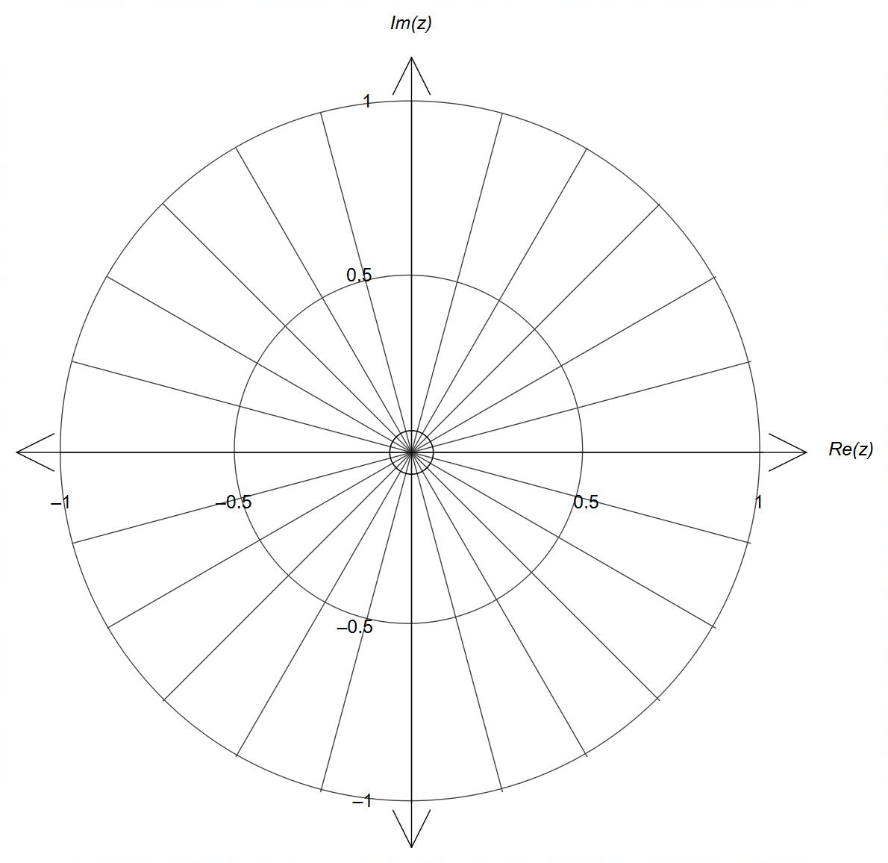

**Question 3 (11 marks)**

(a) Determine the coordinates of the point of intersection of the three planes given below.

(3 marks)

$\begin{matrix}x+y+z=1 \\ 2x+2y+z=2 \\ x-2y-z=1\end{matrix}$

(b) Determine the condition(s) on the constants $m$ and $n$ so that the planes below intersect at a unique solution. Show working to justify your answer. (3 marks)

$\begin{matrix}x+y+z=m \\ 2x+2y+nz=2 \\ x-2y-z=1\end{matrix}$

**(Question 3 – Continued)**

(c) The plane $2x-y+z=4$ is perpendicular to the line $r=\left(\begin{matrix}2 \\ -2 \\ 1\end{matrix}\right)+λ\left(\begin{matrix}a \\ b \\ c\end{matrix}\right)$.

(i) State a possible set of values for the constants $a, b$ and $c$. (2 marks)

(ii) Determine the coordinates of the point of intersection between the line and the plane.

(3 marks)

**Question 4 (11 marks)**

The function $f\left(x\right)=\frac{k\left(x+a\right)\left(x+b\right)}{\left(x+c\right)\left(x+d\right)}$ is shown below, where $a, b, c, d, k∈R$

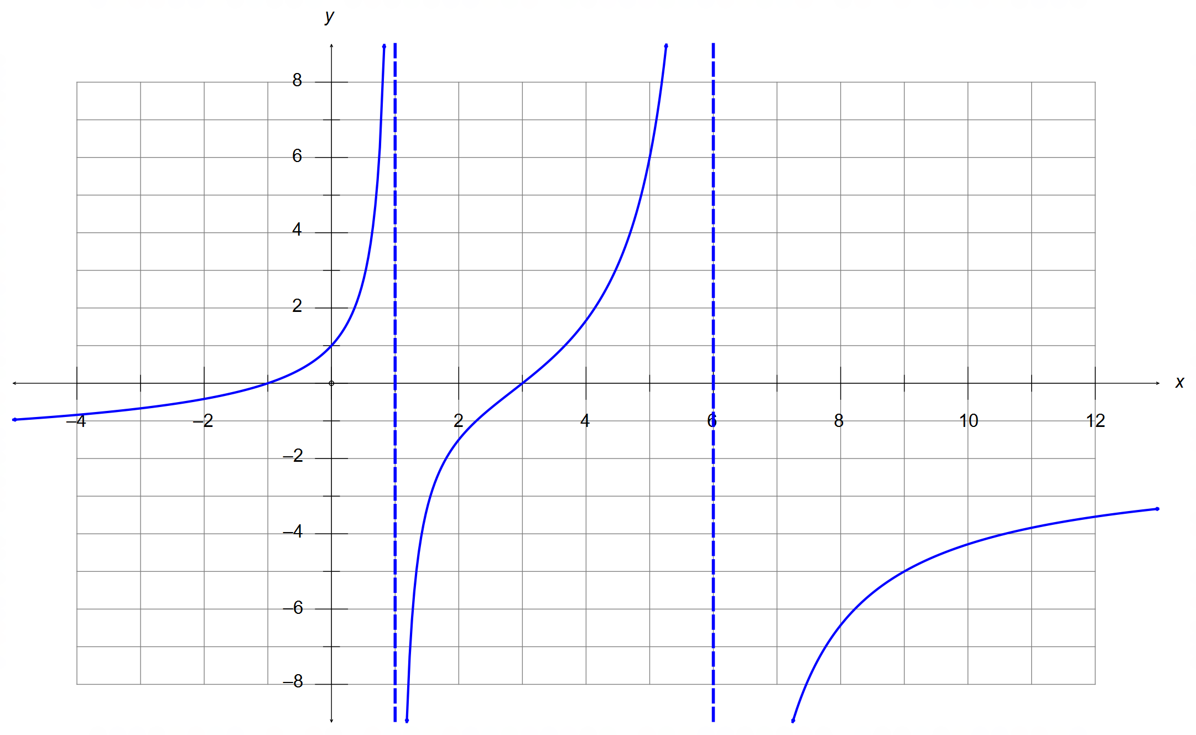

(a) State the value of the constants $a, b, c, d$ and $k$. (5 marks)

**(Question 4 – Continued)**

(b) Sketch the graph of $\frac{1}{f\left(x\right)}$ on the grid provided below. (5 marks)

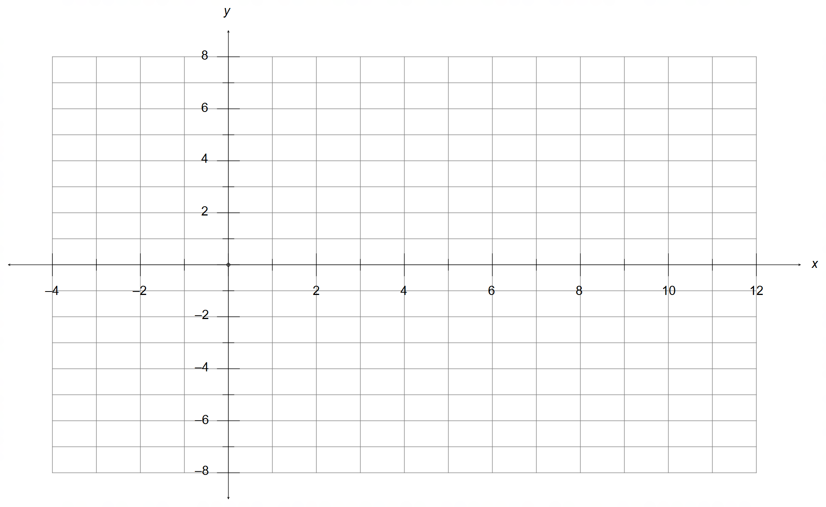

(c) Solve the equation $f\left(\left|x\right|\right)=0$. (1 mark)

**Question 5 (8 marks)**

Two functions $f\left(x\right)$ and $g\left(x\right)$ are defined and graphed below for the restricted domains shown.

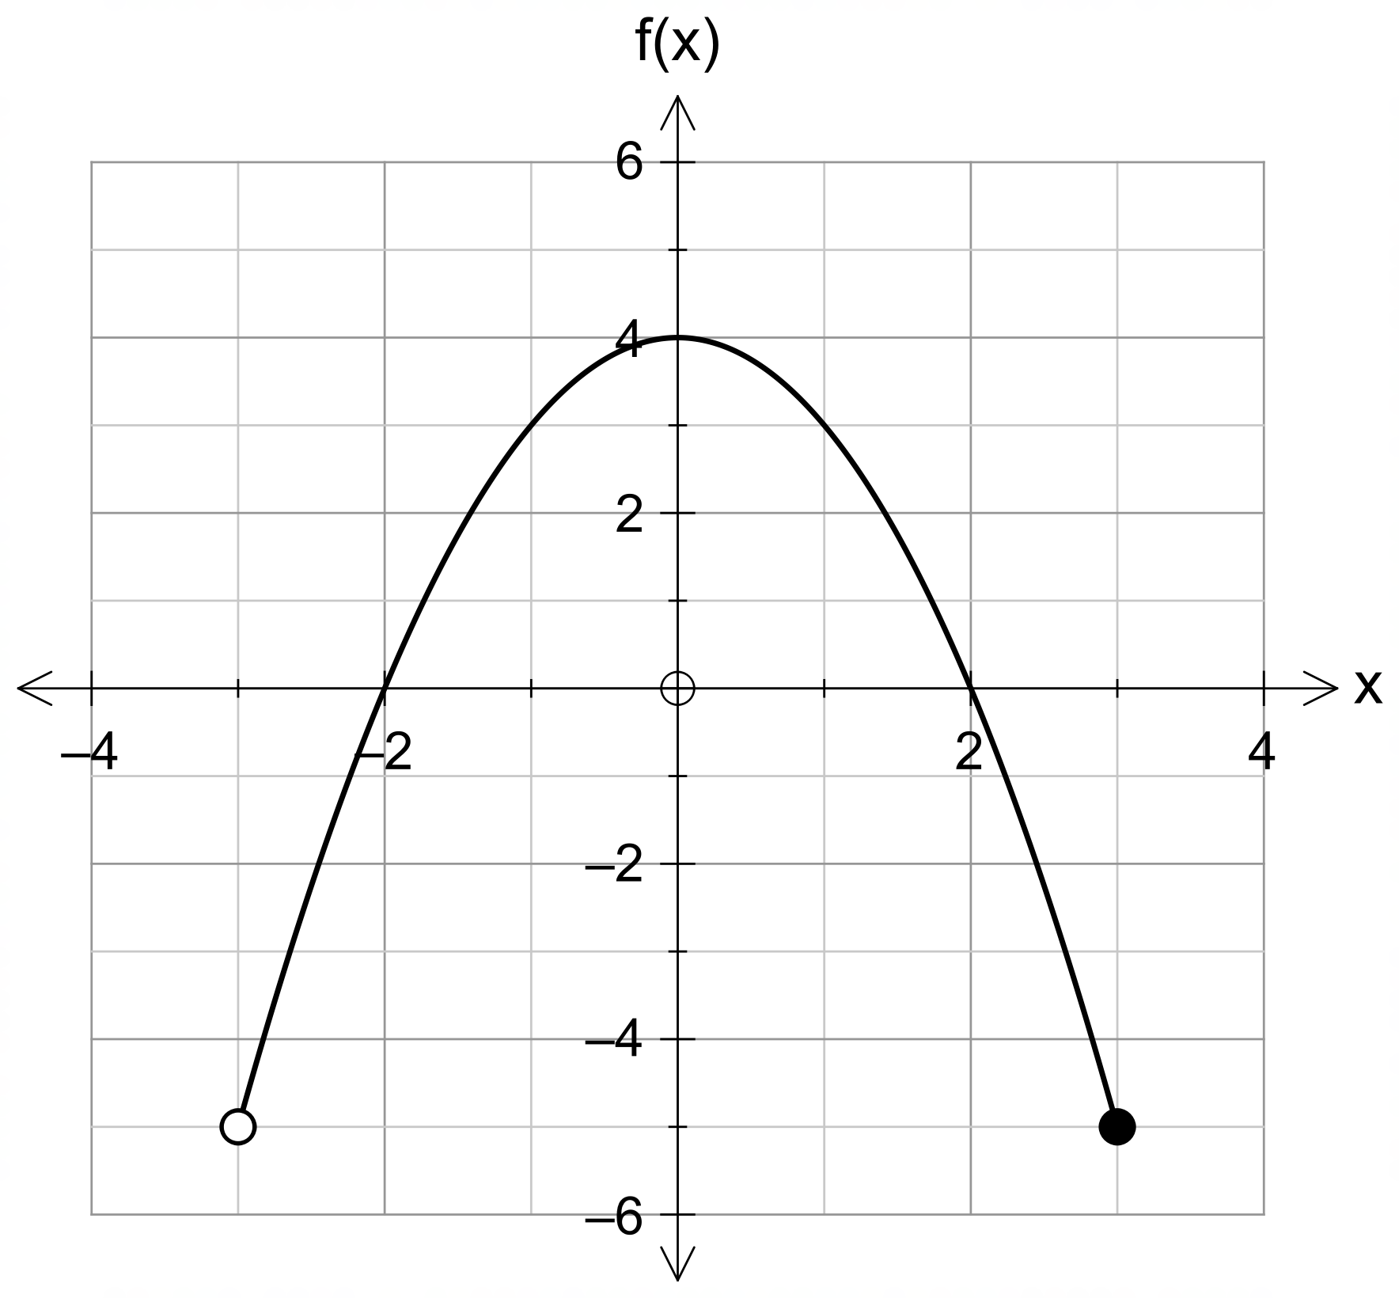

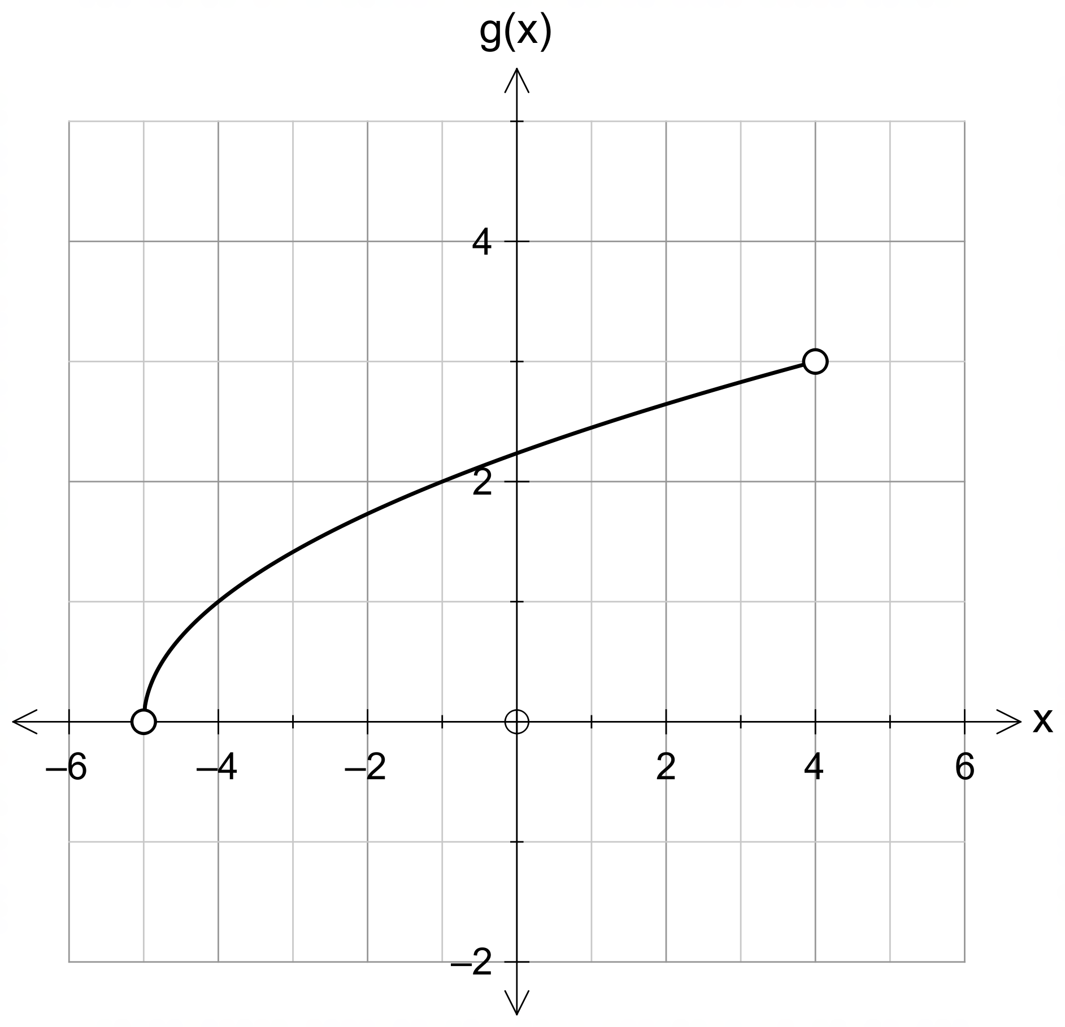

(a) Determine the value(s) of $k$ for which $f∘g\left(k\right)=0$. (2 marks)

(b) Determine the equation that represents $gf\left(x\right)$. (2 marks)

**(Question 5 – Continued)**

(c) Determine the domain required for $gf(x)$ to exist, and hence determine the range of $gf\left(x\right)$.

(4 marks)

**Question 6 (6 marks)**

Points P and Q have respective position vectors $\left(\begin{matrix}3 \\ -1 \\ 2\end{matrix}\right)$ and $\left(\begin{matrix}7 \\ 1 \\ 0\end{matrix}\right)$.

(a) Determine the vector equation of the sphere that has PQ as diameter. (3 marks)

(b) Determine the Cartesian equation of the plane that is tangent to the sphere in (a) at the

point P. (3 marks)

**End of Section One**

**Additional working space**

Question number(s): ……………………

**Additional working space**

Question number(s): ……………………

**Additional working space**

Question number(s): ……………………

**Additional working space**

Question number(s): ……………………